Name : Hadiya Naeem
Roll no: SU92- BSAIM-F25-078
Section: BSAI-3B
Lab task 1

Introduction:
Artifical Intelligence is a technology that helps computers to do task as a human does.

AI timeline:
year | event | Explanation
1950 | Turing test | Alan turning tests for machince intelligence though converstion
1956 | Dartmouth conference | AI become a research field
1974_1980 | First AI winter | AI research faces redused fund
1980’s | Exoert system | AI used human knowledge
2012 | Deep learning | Deep learning successfully by image recognization
Rule base program:
A rule base system make decision on fixed condition.
Program
# the new conditions awhich are added are attendance and fee_paid
def scholarship(score, documents_complete,attendance,fee_paid ):
if score >= 70 and documents_complete == True and attendance >=70 and fee_paid == True:
return "Review"
else: "Hold"
# four case test
cases = [
("pass", 90, True,79,True),
("documents_complete failure", 75 , False ,74, False),
("attendance", 86, True, 75, True),
("fee_paid", 76, True, 67, False ),
]
for name , score, documents_complete , attendance , fee in cases:
result = scholarship(score, documents_complete,attendance, fee )

print ("score",score,
"documents_complete", documents_complete,
"attendance", attendance ,
"fee_paid", fee,
"result",result
)

Output:
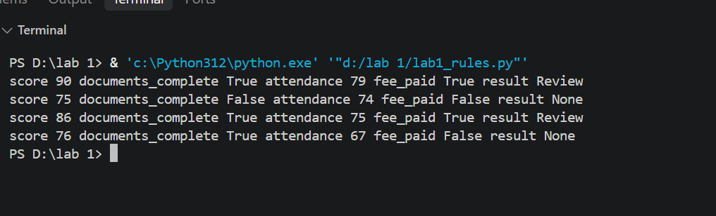
Four test cases:
Test case | Input condition | Expected result | Actual result
Pass | All condition satisficed | Review | Review
Document | Doucments incomplete | Hold | Hold
Attendance | Attendance 60 | Hold | Hold
Fee paid | Marks exactly 70 | review | Review
program
def symbolic(score, complete):
if complete and score >= 70:
return "Review"
else: "Hold"

def threshold(probability):
if probability >= 0.70 :
return "Review"
else: "Hold"

cases = [
("complete_high", 82, True, 0.81),
("complete_low", 68, True, 0.74),
("incomplete_high", 91, False, 0.88),
("boundary", 70, True, 0.70)]

print("case | symbolic | threshold | disagreement")

for name, score, complete, probability in cases:
a = symbolic(score, complete)
b = threshold(probability)

print( name, a, b, a != b, sep=" | ")

def symbolic(score, complete):
return "Review" if complete and score >= 70 else "Hold"

def threshold(probability):
return "Review" if probability >= 0.70 else "Hold"

cases = [
("complete_high", 82, True, 0.81),
("complete_low", 68, True, 0.74),
("incomplete_high", 91, False, 0.88),
("boundary", 70, True, 0.70)
]

print("Case | Symbolic | Threshold | Disagreement")

for name, score, complete, probability in cases:
a = symbolic(score, complete)
b = threshold(probability)

print(name, a, b, a != b, sep=" | ")

output
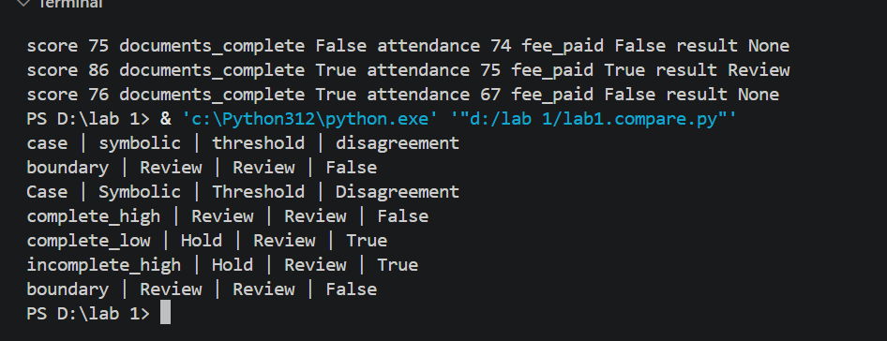

Edge case:
One possible failure in scholarship is incorrect information or wrong date enter.

